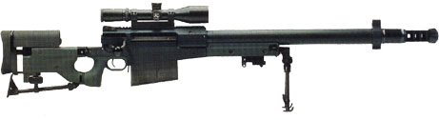
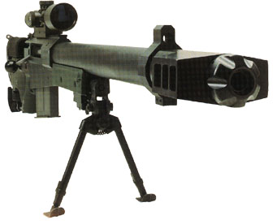
AW50
Ammo | Mag | Rng | ROF | Dam | Arm
.50 BMG  .50 SLAP | 10  10 | 160  160 | 1  1 | 6  6 | -  ½
AW50: The AW50 rifle is based on the same design and ergonomic principles as the other rifles in the AW family, made by Accuracy International, and is constructed to function reliably with all the various natures of commercial and ex-military stock .50 caliber ammunition. Features include a built-in anti-recoil system and an adjustable third supporting leg to help precision in aiming, as well as a folding stock and a total weight (less ammo) of 16Kg (35lbs).
Nation: United Kingdom / Sweden Weight: 16 kg
Ammunition: .50 BMG/.50SLAP Magazine: 10
Price: $11,000 Availability: ( -/- )
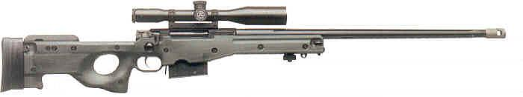
AWM / L115A1
Ammo | Mag | Rng | ROF | Dam | Arm
.338 L | 5 | 100 | 1 | 5 | -
Arctic Warfare Super Magnum: The .338 Lapua Version of the AWP. Accuracy International has made a breakthrough with the AW series rifles. From the Standard to the .50 caliber these weapons are make themselves known and loved in the sniper world. Many gunsmiths have referred to this series as the “boring” rifle because of its consistent accuracy and low maintenance.
Nation: United Kingdom / Sweden Weight: 6.8 kg
Ammunition: .338 Lapua Magazine: 5
Price: $8000 Availability: ( R/R )
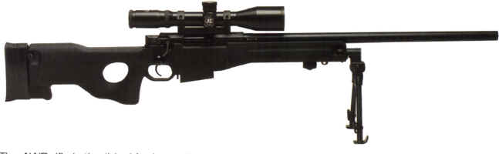
AWP / L96A1
Ammo | Mag | Rng | ROF | Dam | Arm
7.62N | 5 | 75 | 1 | 4 | -
Arctic Warfare / L96A1: In mid-1980s Sweden forces began their own quest for the new sniper rifle, that could survive heavy nordic environments. The AI again become the winner in this race with improved L96 design, named "Arctic warfare". In 1988 Swedish forces adopt AW rifle in 7.62mm NATO chambering. British Army, in its turn, also adopted this improved design under the designation of L96A1.
Nation: United Kingdom / Sweden Weight: 6.3 kg
Ammunition: 7.62N Magazine: 5
Price: $5000 Availability: ( S/S )
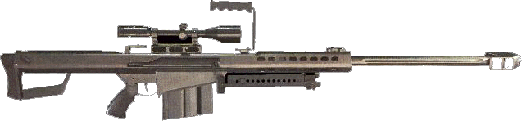
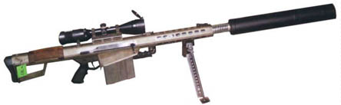
Barrett Model 82A1
Ammo | Mag | Rng | ROF | Dam | Arm
.50 BMG  .50 SLAP | 10  10 | 150  150 | 2  2 | 6  6 | -  ½
M82A1: The Barrett Model 82 has been in service for more than a decade and a half. This weapon is great for long range shots and taking out small helicopters and light/unarmored vehicles (as well as an infantryman or 20). Players must be reminded of its bulk and LOUD shots.
Nation: United States Weight: 13 kg
Ammunition: .50 BMG / SLAP Magazine: 10
Price: $8000 Availability: ( R/- )

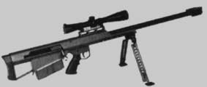
Barrett Model 95
Ammo | Mag | Rng | ROF | Dam | Arm
.50 BMG  .50 SLAP | 5  5 | 150  150 | 1  1 | 6  6 | -  ½
Model 95: A bullpup, bolt-action version of the M82A1. It’s lighter and less bulky then the M82A1 with the same powerful punch, and even with the shorter barrel, the bolt-action gives this weapon the same “reach-out-n-touch-ya” range.
Nation: United States Weight: 11.6 kg
Ammunition: .50 BMG / SLAP Magazine: 5
Price: $3600 Availability: ( S/R )

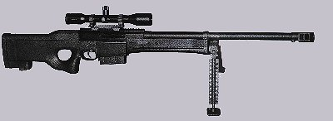
Barrett Model 98
Ammo | Mag | Rng | ROF | Dam | Arm
.338 Lapua | 10 | 90 | 2 | 5 | -
Model 98: Barrett breaks the ice again with a semi auto .338 Lapua sniper rifle. The weapon is more powerful than the standard sniper rifles and weighs much less than the .50 caliber behemoths.
Nation: United States Weight: 7.0 kg
Ammunition: .338 L Magazine: 10
Price: $3500 Availability: ( -/- )
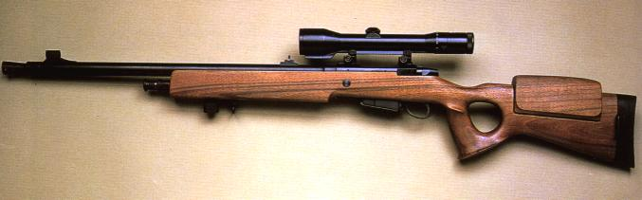
Beretta 501
Ammo | Mag | Rng | ROF | Dam | Arm
7.62N | 5 | 65 | 1 | 4 | -
Beretta 501: The Beretta model 501 sniper rifle was designed on the basis of the Beretta sporting rifle, and was intended for military and police use. manufacturing began in 1985 and now is discontinued and the rifle is replaced in service with Italian army with Accuracy International Arctic Warfare Magnum rifles.
Nation: Italy Weight: 5.5 kg
Ammunition: 7.62N Magazine: 5
Price: $3500 Availability: ( -/- )
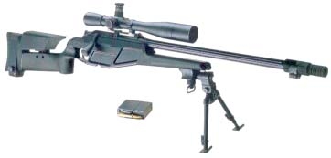
Blaser R93 Tactical
Ammo | Mag | Rng | ROF | Dam | Arm
7.62N  .338 L | 5  5 | 75  100 | 2  1 | 4  5 | -  -
Blaser R93: The R93 is an extremely accurate weapon. The bolt is a straight pull action that allows a faster second shot than that of a standard bolt action. The R93 also features quick interchangeable barrels that allow the usage of the standard 7.62N round or the more powerful .338 Lapua round. The operator can change barrels in about a minute. This is a fair weather rifle. Keep it clean.
Nation: Germany Weight: 5.0 kg
Ammunition: 7.62N/.338L Magazine: 5 / 5
Price: $2995 Availability: ( -/- )

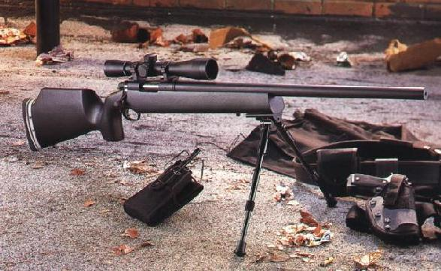
Brown Precision Tactical Elite
Ammo | Mag | Rng | ROF | Dam | Arm
5.56N  7.62N | 4 I  4 I | 60  75 | 1  1 | 2  4 | -  -
Brown Precision Tactical Elite: Brown Precision made its niche as a police sniper rifle. Some elite military units have requested this weapon to be used on selected missions. Good accuracy (see range) and the use of easily found ammunition make it a great weapon.
Nation: United States Weight: 4.3 / 4.6 kg
Ammunition: 5.56N / 7.62N Magazine: 4 I/ 4 I
Price: $1700 / $1900 Availability: ( R/- )
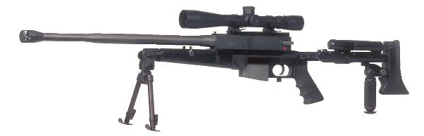
Commando II
Ammo | Mag | Rng | ROF | Dam | Arm
7.62N | 10 | 80 | 1 | 4 | -
Commando II: PGM Ultima Ratio’s Commando II is a smaller and lighter version of the Intervention.
Nation: France Weight: 5.0 kg
Ammunition: 7.62N Magazine: 10
Price: $3000 Availability: ( - / - )
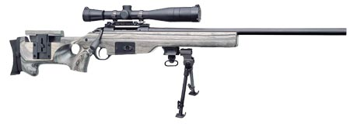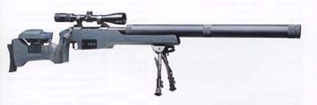
CZ 700 M1 / 700S*
Ammo | Mag | Rng | ROF | Dam | Arm
7.62N  *7.62N | 10  10 | 75  65 | 1  1 | 4  4 | -  x2
CZ 700 M1 / 700S*: Kid tested; mother approved. This excellent sniper rifle has been proven combat worthy and holds up well in inclement weather. The M700 series was developed by Czheska Sbojevka – Uhersky Brod and is known for its exceptional accuracy. The 700S is the silenced version.
Nation: Czechoslovakia Weight: 5.4 kg
Ammunition: 7.62N Magazine: 10
Price: $2100 Availability: ( -/R )
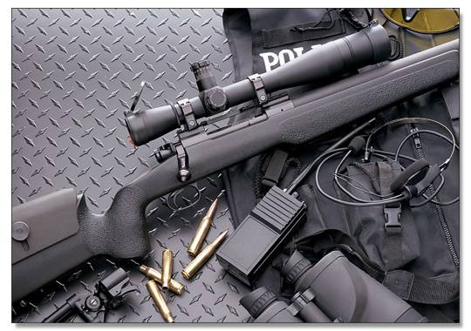
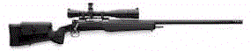
Dakota Longbow
Ammo | Mag | Rng | ROF | Dam | Arm
.338 L | 1 I | 130 | 1 | 5 | -
Dakota Longbow: The Longbow was developed from the ground up at the request of one of the world's more sophisticated governments, seeking a tactical military rifle of unprecedented accuracy, power and flexibility.
Nation: United States Weight: 6.0 kg
Ammunition: .338 L Magazine: 1 I
Price: $4200 Availability: ( R/- )
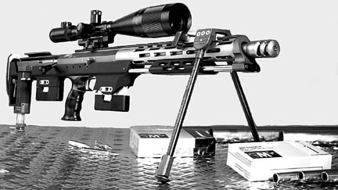
DSR-1
Ammo | Mag | Rng | ROF | Dam | Arm
7.62N  .338 L | 5  4 | 70  90 | 2  2 | 4  5 | -  -
DSR-1: German company AMP Technical Services had originally designed this weapon as a special police sniper rifle. It was soon adopted by the GSG-9 counter terror group and even the Navy SEALS. The weapon has a bull-pup configuration with an extra magazine holder forward of the trigger guard. The barrels are interchangeable and can be done in seconds.
Nation: Germany Weight: 6.0 kg
Ammunition: 7.62N / .338 L Magazine: 5 / 4
Price: $4500 Availability: ( -/- )

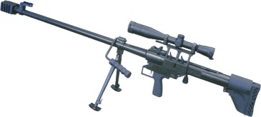
Falcon OP 96 / OP 99*
Ammo | Mag | Rng | ROF | Dam | Arm
.50 BMG  .50 SLAP  *12.7 | 2 I  2 I  2 I | 130  130  200 | 1  1  1 | 6  6  7 | -  ½  -
Falcon OP96 / OP99: The Falcon rifle is manufactured by ZVI in Czech Republic. The rifle is manufactured in two variants - OP 96 for NATO-standard .50BMG cartridge, and OP 99 for Eastern block standard Russian 12.7x108mm cartridge. Falcon is made in bull-pup configuration. It has Mauser-type, three lugs bolt. Built-in 2 round magazine may be blocked by special cover to convert rifle to single-shot mode. Falcon has mounts for various telescopic sights, as well as back-up iron sights. To reduce felt recoil, Falcon is equipped with muzzle brake and spring-powered recoil pad in butt-stock.
Nation: Czechoslovakia Weight: .55 / .60 kg
Ammunition:.50 BMG/SLAP / 12.7 Magazine: 2 / 2 / 2
Price: $5,000/10,000 Availability: ( -/- )

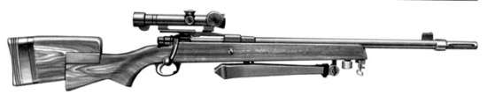
FN 30-11
Ammo | Mag | Rng | ROF | Dam | Arm
7.62N | 5 I | 60 | 1 | 4 | -
FN 30-11: Fabrique Nationale did it again when they made this hybrid weapon. It is a cross between the ever popular and effective Mauser and the FN-30. Very few modifications have been made since its service entry date in 1976. If it ain’t broke…
Nation: Belgium Weight: 4.85 kg
Ammunition: 7.62N Magazine: 5 I
Price: $500 Availability: ( S/C )

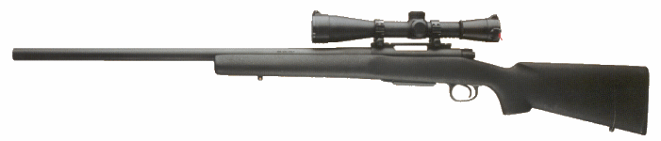
FN PS (Police Special)
Ammo | Mag | Rng | ROF | Dam | Arm
7.62N | 5 | 70 | 1 | 4 | -
FN PS: The standard sniper rifle of the Belgium police. This weapon is made of high grade, corrosion resistant metals and a polymer stock which make it durable in rough field conditions. It’s lightweight, has an excellent range and needs minimal care. All that and the use of the commonly found 7.62N round leave the owners of this masterpiece feeling warm and fuzzy.
Nation: Belgium Weight: 4.5 kg
Ammunition: 7.62N Magazine: 5
Price: $1200 Availability: ( R/S )

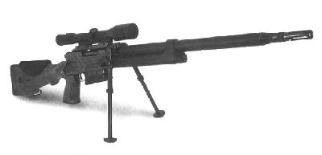
FR – F2
Ammo | Mag | Rng | ROF | Dam | Arm
7.62N | 10 | 65 | 2 | 4 | -
FR-F2: The F2 took the place of the F1 as the standard sniper rifle for both the military and police of France. The PGM Intervention and Commando II as well as the Accuracy International AW series later replaced both the F1 and F2.
Nation: France Weight: 5.75 kg
Ammunition: 7.62N Magazine: 10
Price: $1800 Availability: ( S/S )

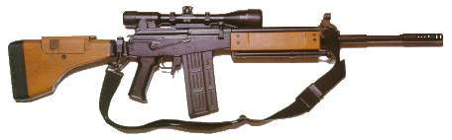
Galatz
Ammo | Mag | Rng | ROF | Dam | Arm
7.62N | 20 | 75 | 3 | 4 | -
Galatz: The Galatz is more commonly known as the Galil sniper rifle. This weapon was designed by IMI to not only survive some of the harshest conditions, but to out perform other weapons in these conditions. It’s durability and accuracy (as well as the IMI name) make it a greatly desired weapon.
Nation: Israel Weight: 5.0 kg
Ammunition: 7.62N Magazine: 20
Price: $2300 Availability: ( S/S )
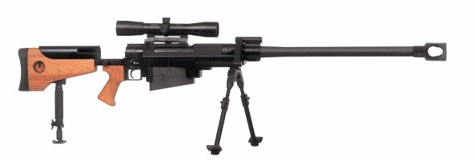
Hecate II
Ammo | Mag | Rng | ROF | Dam | Arm
.50 BMG  .50 SLAP | 7  7 | 150  150 | 1  1 | 6  6 | -  ½
Hecate II: The PGM Ultima Ratio Hecate II rifle a utilizes “metallic skeleton” design similar to other UR rifles only it has been scaled up greatly. The Hecate II is France’s response to the growing variety of extremely high caliber sniper rifles. The Hecate II was France’s main .50 caliber sniper rifle, until it also adopted the AW50 shortly before the outbreak of the war..
Nation: France Weight: 13.8 kg
Ammunition: .50 BMG / SLAP Magazine: 7
Price: $8100 Availability: ( -/- )

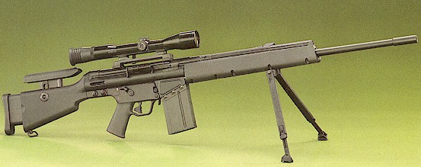
HK MSG90
Ammo | Mag | Rng | ROF | Dam | Arm
7.62N | 10 | 65 | 2 | 4 | -
HK MSG90: The abbreviation MSG stands for "Militarisch Scharfschutzen Gewehr" in German or Military Marksman Rifle in English. "90" is for the year of initial production.
MSG90 was designed as a cheaper alternative to the well-known PSG-1 rifle. Based on the same old G3 design, MSG90 features PSG1 trigger group, but has smaller and lighter buttstock and lighter barrel.
Nation: Germany Weight: 6.4 kg
Ammunition: 7.62N Magazine: 10
Price: $4100 Availability: ( S/S )
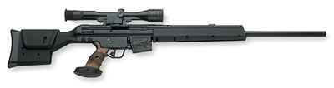
HK PSG1
Ammo | Mag | Rng | ROF | Dam | Arm
7.62N | 10 | 70 | 2 | 4 | -
HK PSG1: The standard sniper rifle of Germany. The PSG1 has had wide-spread fame and lead to it becoming one of the most popular and sought after weapons of our day. It is accurate and comfortable. Plus it looks really cool. The PSG1 has been adopted by different agencies and units world wide.
Nation: Germany Weight: 8.0 kg
Ammunition: 7.62N Magazine: 10
Price: $5600 Availability: ( S/S )
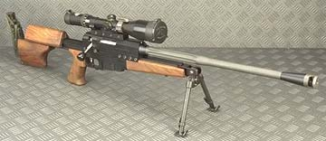
Intervention
Ammo | Mag | Rng | ROF | Dam | Arm
7.62N | 10 | 75 | 1 | 4 | -
Intervention: PGM Ultima Ratio’s Intervention, together with the Commando and the Hecate II were France’s trio sniper weapon systems for several years. The intervention was the standard and the other two were mission specific weapons.
Nation: France Weight: 6.0 kg
Ammunition: 7.62N Magazine: 10
Price: $5600 Availability: ( S/R )

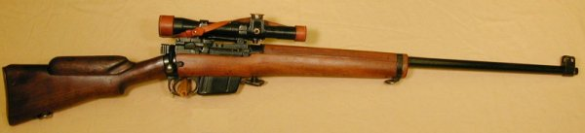
L42A1
Ammo | Mag | Rng | ROF | Dam | Arm
7.62N | 10 | 75 | 1 | 4 | -
L42A1: The Enfield L42A1 was Great Britain’s main sniper rifle until it was replaced in 1985 by the L96. This weapon is still widely used in Europe.
Nation: United Kingdom Weight: 4.42 kg
Ammunition: 7.62N Magazine: 10
Price: $1800 Availability: ( C/S )

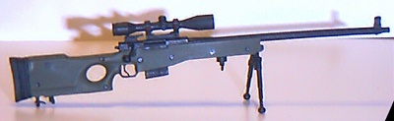
L96 / L96A1
Ammo | Mag | Rng | ROF | Dam | Arm
7.62N | 5 | 75 | 1 | 4 | -
L96 / L96A1: The L96 replaced the Parker Hale as the standard sniper rifle for UK forces. In mid-1980s Sweden forces began their own quest for the new sniper rifle, that could survive heavy Nordic environments. The AI again become the winner in this race with improved L96 design, named "Arctic warfare". In 1988 Swedish forces adopt AW rifle in 7.62mm NATO chambering. British Army, in its turn, also adopted this improved design under the designation of L96A1. Also adopted by other countries (Italy, Belgium, Australia, Canada, Denmark, France, Malaysia, the Netherlands, Oman, Spain and more).
Nation: United Kingdom / Sweden Weight: 6.3 kg
Ammunition: 7.62N Magazine: 5
Price: $5000 Availability: ( S/S )
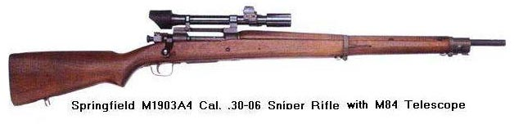
M1903A4
Ammo | Mag | Rng | ROF | Dam | Arm
.30-06 | 5 I-Box | 65 | 1 | 4 | -
M1903A4: Springfield Armory designed this weapon to meet the need for sniper rifles in the Pacific combat during World War II. It was adopted in 1943 and Springfield produced them with 2.5x telescopic scopes. This weapon carried on into Korea and the early stages of Vietnam.
Nation: United States Weight: 4.3 kg
Ammunition: .30-06 Magazine: 5 Box
Price: $Negotiable Availability: ( R/R )
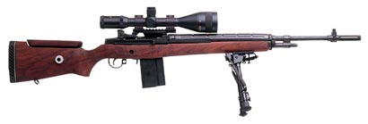
M21
Ammo | Mag | Rng | ROF | Dam | Arm
7.62N | 10 / 20 | 60 | 3 | 4 | -
M21: The M21 is essentially a modified M14 National Match rifle. M21 is a very practical sniper weapon maintaining acceptable accuracy out to about 700 meters. Besides the problem that it is semi-auto and sends brass flying, the M21 was, and still is, a very capable military sniper rifle. There is an improved version of this rifle, the M25. That was the issued sniper rifle of SEAL units during Operation Desert Storm. The M21 began to be fielded in the second half of 1969 and remained the U.S. Army's primary Sniper Weapon System until it began to be replaced by the M24 SWS in 1988.
Nation: United States Weight: 5.11 kg
Ammunition: .7.62N Magazine: 10 / 20
Price: $ 2900 Availability: ( S/R )
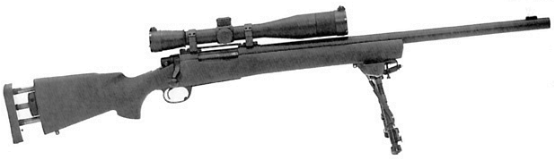
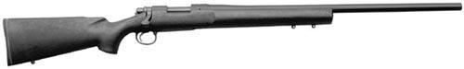
M24 / Remington 700 / M40
Ammo | Mag | Rng | ROF | Dam | Arm
7.62N | 5 I | 75 | 1 | 4 | -
M24 / M40: The M24 Sniper's Weapon System (SWS) represents a return to bolt action sniper rifles by the US Army. As in the USMC M40A1, the M24 uses the Remington 700 action, although the receiver has been made for adaptation to take the 7.62N round. The stock is made of a composite of Kevlar, graphite and fiberglass bound together with epoxy resins, and features an aluminum bedding block and adjustable butt plate. A detachable bipod (Harris) can be attached to the stocks fore-end.
Nation: United States Weight: 5.49 kg
Ammunition: 7.62N Magazine: 5 I
Price: $2800 Availability: ( C/S )
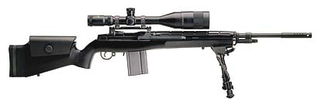
M25
Ammo | Mag | Rng | ROF | Dam | Arm
7.62N | 20 | 70 | 3 | 4 | -
M25: The M25 is a joint venture sniper rifle, built for both the US Army Special Forces and the US Navy SEALs. It was originally developed by the 10th SFG base at Ft. Devens in response to a requirement for a match grade M14 for Special Forces sniper teams. USSOCCOM was dubbing the rifle the "Light Sniper Rifle", and its also known as the "Sniper Security System" and "Product Improved M21". It is very similar to the M21, only a few modification have been made that increase range and durability in the field.
Nation: United States Weight: 4.9 kg
Ammunition: 7.62N Magazine: 20
Price: $3800 Availability: ( R/- )

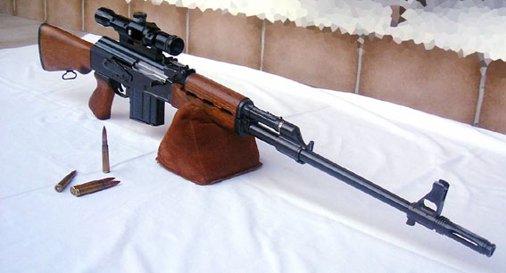
M-76
Ammo | Mag | Rng | ROF | Dam | Arm
7.62L | 10 | 65 | 2 | 4 | -
M-76: Yugoslavia designed this from the rugged AK47 frame. It really uses 7.92 rounds, but they aren’t in the game.
Nation: Yugoslavia Weight: 4.8 kg
Ammunition: 7.62L Magazine: 10
Price: $2100 Availability: ( -/S )

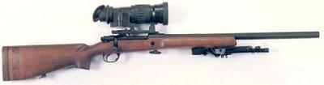
M82
Ammo | Mag | Rng | ROF | Dam | Arm
7.62N | 4 I | 75 | 1 | 4 | -
M82: This weapon is the standard sniper rifle of the Canadian military and the former standard of the UK. The Canadian Military’s version is called the C3A1 has a different scope. The C3A1 / M82 is a very popular weapon and is used by many nations (Australia, Great Britain, New Zealand, United States, etc.). It is usually hailed as the Parker Hale and all respect it.
Nation: Canada Weight: 4.8 kg
Ammunition: 7.62N Magazine: 4 I
Price: $1700 Availability: ( C/S )

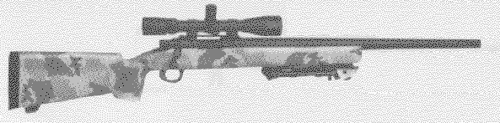
M86
Ammo | Mag | Rng | ROF | Dam | Arm
7.62N | 4 I | 75 | 1 | 4 | -
Harris Gunworks M86: Harris Gunworks is a break off from McMillan, and they continue to make high quality firearms. The M86 has been employed by the Navy SEALS and other special forces units, and uses the McMillan McHale stock. Harris makes several other standard models along with custom firearms
Nation: United States Weight: 5.0 kg
Ammunition: 7.62N Magazine: 4
Price: $1895 Availability: ( S/R )

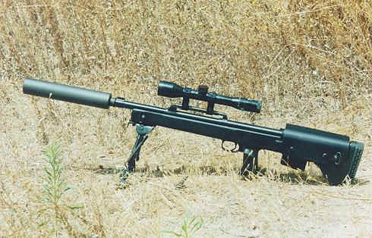
M89-SR
Ammo | Mag | Rng | ROF | Dam | Arm
7.62N  7.62N* | 10  10 | 75  65 | 2  2 | 4  4 | -  x2
M89-SR: The M89-SR is designed as a dual-purpose weapon. Designed for both urban anti-terrorist operations as well as a battlefield sniper rifle. The rifle is based on the M-14 rifle in a bull-pup configuration. Sound suppressor is standard and the stats are shown with *.
Nation: Israel Weight: 4.5 kg
Ammunition: 7.62N Magazine: 10
Price: $6500 Availability: ( R/- )
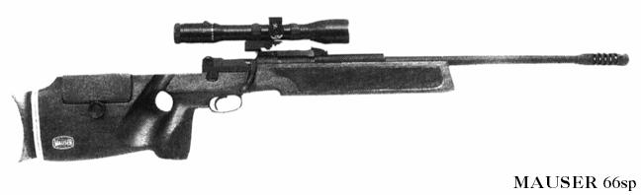
Mauser SP66
Ammo | Mag | Rng | ROF | Dam | Arm
7.62N | 3 I | 75 | 1 | 4 | -
Mauser SP66: The SP66 was designed and intended for both military and law enforcement use. It is a well made rifle, with a beautiful and very practical contoured wood stock. The SP66 is similar to, and can trace some of its roots back to, some competition rifles. The rifle uses the Mauser short action with a very fast lock time, which is critical to accurate shooting. The rifle has a high reputation for being extremely accurate, and comfortable to shoot.
Nation: Germany Weight: 6.2 kg
Ammunition: 7.62N Magazine: 3 I
Price: $3400 Availability: ( -/- )

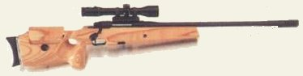
Mauser 86SR
Ammo | Mag | Rng | ROF | Dam | Arm
7.62N | 9 | 70 | 1 | 4 | -
Mauser 86SR: This rifle was developed in Germany on the Mauser Sporting rifle. Used by Germany and Italy police, as well as by Israeli Special Forces (Isayeret) and many other Europe law enforcement forces.
Nation: Germany Weight: 4.9 kg
Ammunition: 7.62N Magazine: 9
Price: $2800 Availability: ( -/- )

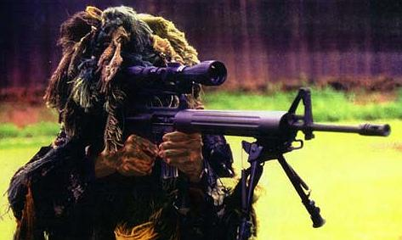
MSSR1
Ammo | Mag | Rng | ROF | Dam | Arm
5.56N | 20/30 | 60 | 4 | 2 | -
MSSR1: The MSSR was developed out of a need for a designated sniper rifle for the Landing Battalions of the Filipino Marines. They were operating on a limited budget, and didn't have the expert gunsmiths to modify a M14 or any of the other standard rifles used for sniping. But they do have the experts who know how to work on M16's, so that’s what they did.
Nation: Philippines Weight: 4.5 kg
Ammunition: 5.56N Magazine: 20/30
Price: $3200 Availability: ( -/- )

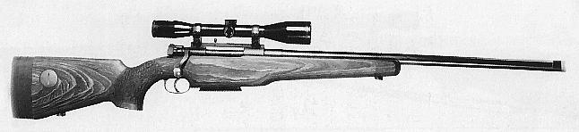
NM149s
Ammo | Mag | Rng | ROF | Dam | Arm
7.62N | 5 | 70 | 1 | 4 | -
NM149s: The NM149S Vapensmia was developed in close cooperation with the Norwegian Army and is based on the tried and true M98 bolt action. The stock is adjustable for length of pull via a spacer system, and the barrel is of heavy contour and the system shoots very well. There was a problem with the early versions with the stock cracking, but that problem has since been solved. The system is very capable and effective and has been serving in the Norwegian army since 1988.
Nation: Norway Weight: 5.6 kg
Ammunition: 7.62N Magazine: 5
Price: $1400 Availability: ( -/- )
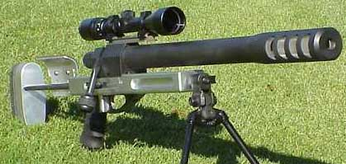
Rebel .50
Ammo | Mag | Rng | ROF | Dam | Arm
.50 BMG  .50 SLAP | 1 I  1 I | 120  120 | 1  1 | 6  6 | -  ½
Rebel .50: The Rebel can be shortened for carrying by removing the rear half of the buttstock. The stock is machined from aircraft grade aluminum 6061-T6 solid billet and precision ground tool steel. Both butt ends and cheek pieces are adjustable. Trigger is fully adjustable for weight of pull and length of pull. The cheek-piece is ambidextrous for right or left hand shooters. The pistol grip is a comfortable rubberized AR-15 style grip with finger contours. Finish is standard black. Bi-pod is Versa-pod with a quick detach mount. It allows ample movement for roll, tilt and swing unlike most bi-pods which are rigid or allow only for roll.
Nation: United States Weight: 11 kg
Ammunition: .50 BMG / SLAP Magazine: 1 I
Price: $3600 Availability: ( R/- )

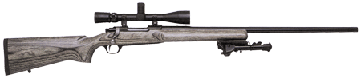
Ruger Mk II VLE (M77)
Ammo | Mag | Rng | ROF | Dam | Arm
7.62N | 5 I | 70 | 1 | 4 | -
Ruger MkII VLE: The Ruger M77 MkII VLE is Ruger's little known Law Enforcement tactical rifle. The rifle is based off of the M77 MkII VT target/varmint rifle but has a few changes that make it more effective in the field. Plus, at this price and light weight it has become a cheap sniper’s throw away tool for any task. Used a lot in missions to just shoot and leave quickly.
Nation: United States Weight: 4.3 kg
Ammunition: 7.62N Magazine: 5 I
Price: $600 Availability: ( C/S )

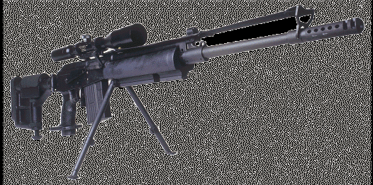
SR-99a
Ammo | Mag | Rng | ROF | Dam | Arm
7.62N | 25 | 55 | 4 | 4 | -
SR-99: IMI released this sniper rifle shortly after the war broke out. Testing was never finished on it and it lacks the range that most snipers want with a rifle. Though designed as a sniper rifle many players treat this as a Battle Rifle because of the capacity, rate of fire and less than satisfactory range.
Nation: Israel Weight: 5.1 kg
Ammunition: 7.62N Magazine: 25
Price: $2800 Availability: ( R/- )

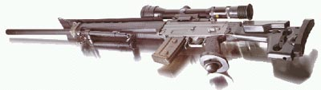
Sig SG550
Ammo | Mag | Rng | ROF | Dam | Arm
5.56N | 20 | 50 | 4 | 2 | -
Sig SG 550: SIG 550 Sniper is a "sniperized" variant of the famous Sig 550/Stg.90 assault rifle, manufactured by SAN Swiss Arms (former Sig Arms, now - a member of the SIGARMS group). The SG550 Sniper is a good short to medium military marksman rifle or police / antiterrorist rifle, capable of quick and accurate follow-up shots.
Nation: Switzerland Weight: 5.4 kg
Ammunition: 5.56N Magazine: 20
Price: $1700 Availability: ( R/S )

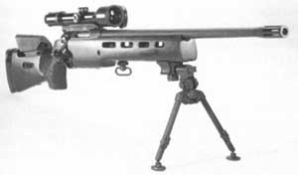
Sig SSG 3000
Ammo | Mag | Rng | ROF | Dam | Arm
7.62N | 5 | 70 | 1 | 4 | -
Sig SSG 3000: Made in Switzerland, the SSG 3000 is a extremely well made rifle. It is modular in design, and the stock is of laminated wood and ventilated. The bolt has six lugs and locks into the barrel. There is a rail under the forearm to take accessories. The rifle comes standard with a Hendsoldt scope, but the rings are standard so that can be switched out. Sig has an extremely good reputation for high quality, accurate weapons.
Nation: Switzerland Weight: 5.4 kg
Ammunition: 7.62N Magazine: 5
Price: $2100 Availability: ( R/R )

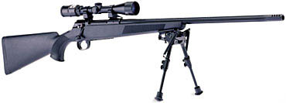
Sig STR 970
Ammo | Mag | Rng | ROF | Dam | Arm
7.62N | 4 | 65 | 1 | 4 | -
Sig STR 970: A modified hunting rifle used by few units in the eastern part of Europe.
Nation: Switzerland Weight: 5.4 kg
Ammunition: 7.62N Magazine: 5
Price: $1200 Availability: ( R/R )

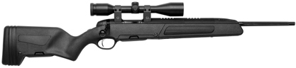
Steyr Scout
Ammo | Mag | Rng | ROF | Dam | Arm
7.62N | 5 / 10 | 60 | 1 | 4 | -
Steyr Scout: This Austria weapon has impressive range and punch for its small size. Excellent weapon to carry on long trips in the field.
Nation: Austria Weight: 3.3 kg
Ammunition: 7.62N Magazine: 5 / 10
Price: $1600 Availability: ( -/- )

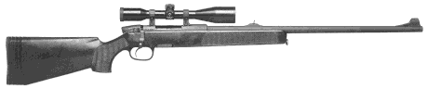
Steyr SSG-P1
Ammo | Mag | Rng | ROF | Dam | Arm
7.62N | 5 / 10 | 70 | 1 | 4 | -
Steyr SSG P-1: Steyr SSG (ScharfShutzenGewehr 69) is produced since 1969, hence is its name. I was developed by Steyr-Daimler-Puch. SSG-69 is the Austrian Army's standard issue sniper rifle, the PI is the civilian version of the same weapon. It is also used by several police agencies and other military units. It is extremely accurate and several international competitions have been won using an SSG-69.
Nation: Austria Weight: 3.9 kg
Ammunition: 7.62N Magazine: 5 / 10
Price: $1100 Availability: ( R/R )

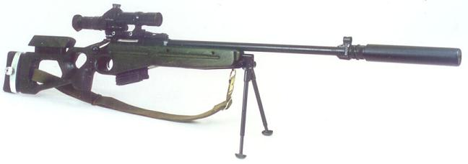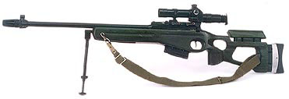
SV98
Ammo | Mag | Rng | ROF | Dam | Arm
7.62N | 10 | 80 | 1 | 4 | -
SV98: SV-98 has iron sights (shrouded front and adjustable ramp rear) and a scope mount. Standard scope is a Russian-made PKS-7 7X fixed magnification scope. Trigger is "sport-style" and adjustable (standard trigger pull is 1.5-2kg). Initial versions has wooden fully adjustable stocks with adjustable cheek piece, later polymer stock could be introduced. Barrel is equipped with removable flash-hider. The weapon is also one of the few Warsaw PACT weapons to use the NATO rounds.
Nation: USSR Weight: 6.2 kg
Ammunition: 7.62N Magazine: 10
Price: $1200 Availability: ( R/R )

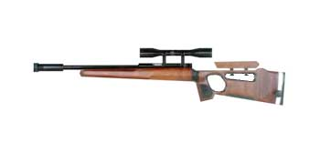
SV99
Ammo | Mag | Rng | ROF | Dam | Arm
.22LR | 10 | 65 | 2 | 0 | x4
SV99: The .22LR has been used in many small urban campaigns as a successful sniping weapon. The Soviet Army created the SV99 for these purposes. It’s quiet and when used with a suppressor the sound is not even noticed (-50% ro RCN rolls). Players may complain that it doesn’t do much damage… that’s what head shots are for.
Nation: USSR Weight: 3.9 kg
Ammunition: .22LR Magazine: 10
Price: $600 Availability: ( R/S )

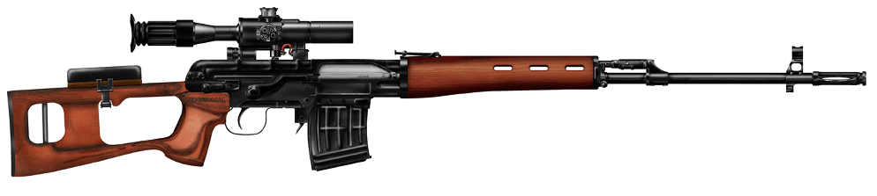
SVD
Ammo | Mag | Rng | ROF | Dam | Arm
7.62L | 10 | 70 | 2 | 4 | -
SvD Dragunov: One of the most popular Sniper Rifles. It’s semi auto to allow a quick second shot and has good range. The SvD has been favored by many snipers around the world. It was officially replaced by the SV98 but many units preferred to keep the Dragunov. One soldier was quoted as saying “If I need better range I’ll use an RPG.”
Nation: USSR Weight: 4.3 kg
Ammunition: 7.62L Magazine: 10
Price: $2800 Availability: ( S/C )

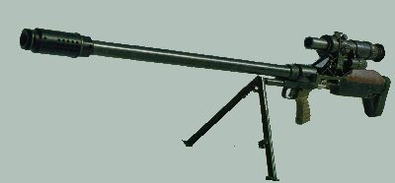
SVN 98
Ammo | Mag | Rng | ROF | Dam | Arm
12.7 | 5 | 200 | 1 | 7 | -
SVN 98: A bolt-action nightmare. The US came to the battlefield with the frightening Barrett M82, the USSR answered with the hellish SVN 98. With a 25% greater range and a bit more punch than the Barrett, the SVN was rushed to the field, almost directly bypassing the experimental testing phase. Keep it maintained. Players should consider maintenance for this weapon double that of a regular long rifle. Fumble is increased one number. (House rules: 97-00 instead of 98-00)
Nation: USSR Weight: 14.3 kg
Ammunition: 12.7 Magazine: 5
Price: $8300 Availability: ( -/- )

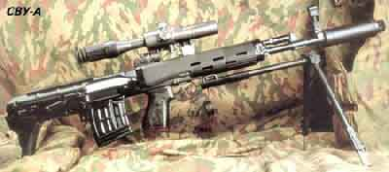
SVU / SVU-A
Ammo | Mag | Rng | ROF | Dam | Arm
7.62L  7.62L | 10  20 | 60  50 | 2  4 | 4  4 | -  -
SVU: The SVU is basically, a shortened variant of famous SVD rifle, re-stocked into bull-pup configuration, with added folding adjustable bipods and muzzle device (flash hider and noise suppressor –15% RCN). SVU-A is SVU with added full-auto capability. It is not intended for long range sniping.
Nation: USSR Weight: 4.3 kg
Ammunition: 7.62L Magazine: 10 / 20
Price: $2200 Availability: ( R/S )

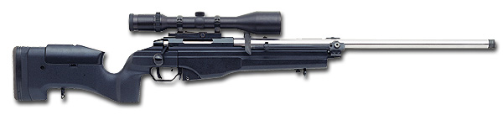
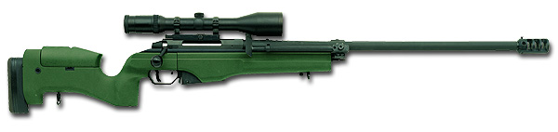
TRG 22 / 42*
Ammo | Mag | Rng | ROF | Dam | Arm
7.62N  .338 L | 10  10 | 70  85 | 1  1 | 4  5 | -  -
TRG 22 / 42: The TRG sniper rifles were developed by Finnish company Sako. Original rifles, TRG-22 and TRG-42, were both built around Sako TRG bolt action, with rotating bolt having three massive lugs at the front. Same action is used in Sako TRG-S hunting rifles. Other key features of the TRG sniper rifles are aluminium bedded, composite stocks with ajustable butts and chheekpieces, heavy, match grade barrels and ajustable triggers. The main difference between TRG-22 and TRG-42 is in ammunition used - the TRG-22 is designed to fire standard 7.62NATO ammunition, and has standard length action, while the TRG-42 is designed to fire more powerful .338 Lapua ammunition, and has large (magnum-size) action and longer barrel with muzzle brake. In all other respects both rifles are similar.
Nation: Finnland Weight: 4.7 / 5.1kg*
Ammunition: 7.62N / .338L Magazine: 10
Price: $2300 / 3500 Availability: ( S/S )

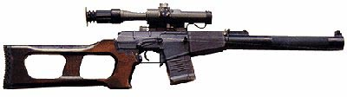
VSS
Ammo | Mag | Rng | ROF | Dam | Arm
9mmP | 10 | 30 | 3 | 1 | x3
VSS: VSS (Vinovka Snaiperskaja Spetsialnaya = Special Sniper Rifle) was designed for special operations. Adopted by Russian Military and Special Law Reinforcement units in 1987. This rifle has integrated silencer. VSS is intended for use at short and medium distances (up to 400 meters with telescope or up to 300 meters with night (IR) sight). Noise level of VSS is as low as 130dB, and is equivalet to noise of .22 unsilenced rifle. VSS was (and is) used in all local conflicts that Russian Army was involved in last decade.
Nation: USSR Weight: 2.6kg
Ammunition: 9mmP Magazine: 10
Price: $1600 Availability: ( -/S )

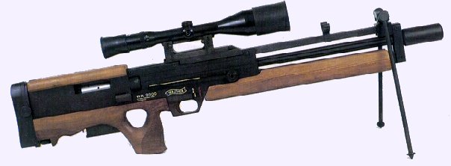
Walther 2000
Ammo | Mag | Rng | ROF | Dam | Arm
7.62N | 6 | 85 | 2 | 4 | -
Walther 2000: Walther Wa-2000 sniper rifle had been developed by Carl Walther Waffenfabrik (Germany) in early 1970s as a highly specialized police sniper rifle. Unlike many other sniper rifles of that period, WA-2000 was not a conversion of the sporting or hunting rifle, but entirely new design with some remarkable features. The gun is built in the bullpup style, to achieve most compact package while maintaining suitably long barrels. Wa-2000 is a semiautomatic rifle, gas operated, with rotating bolt. This give the ability for quick follow-up shots if needed. The heavy, match barrel is fluted and free-floated. The stock and trigger are adjustable, the folding bipod is mounted on the special ramp above the barrel and could be moved forward and back to achieve maximum comfort on position. Overall, the WA-2000 was the very strong and accurate rifle, but unit price was too high and resulting sales were marginal, so it never entered full-scale production.
Nation: Germany Weight: 6.9 kg
Ammunition: 7.62N Magazine: 6
Price: $5500 Availability: ( -/S )

Some Pre-Modified Weapons:

Model 700
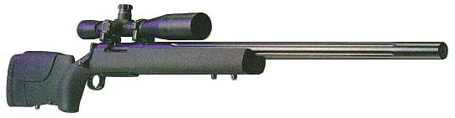
HS Precision Pro 2000 HTR
Ammo | Mag | Rng | ROF | Dam | Arm
7.62N  .338L * | 5 I  4 I | 80  100 | 1  1 | 4  5 | -  -
HTR: This Modified M24 comes with a fluted barrel, a Teflon finish and a modified stock that is more comfortable than the standard issue M24. The weapon can be purchased in 7.62N or .338 Lapua.
Nation: United States Weight: 4.6 / *5.1 kg
Ammunition: 7.62N / *.338L Magazine: 5 I / *4 I
Price: $1900 / *$2100 Availability: ( -/- )
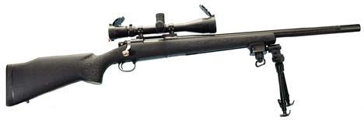
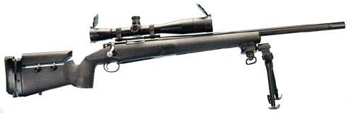
SR 60 and SR 90
Ammo | Mag | Rng | ROF | Dam | Arm
7.62N  .338 L | 5 I  4 I | 80  110 | 1  1 | 4  5 | -  -
SR60 / SR90: Robar unleashed it’s Model 700 variants with power. These weapons were used in pre WWIII outbreaks all over the world by many different Special Forces units.
Nation: United States Weight: 5 kg
Ammunition: 7.62N / .338 L Magazine: 5 I / 4 I
Price: $3200 Availability: ( -/- )

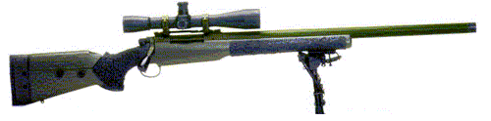
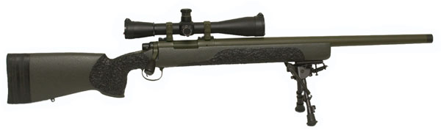
Tactical Operations Alpha 66 / Bravo 51-1
Ammo | Mag | Rng | ROF | Dam | Arm
7.62N | 5 I | 80 | 1 | 4 | -
Alpha 61 / Bravo 51-1: The weapons are basically tweaked Model 700’s. They come standard with an aluminum three-way adjustable butt plate to allow just about any size person to have a truly custom fit rifle. An adjustable spacer system is available as an option. The blueprinted action and aluminum pillar bedding are peerless quality. A heavy cryogenically treated barrel with a match chamber and crown is standard. Barrels are threaded for silencers.
Nation: United States Weight: 5 kg
Ammunition: 7.62N Magazine: 5 I
Price: $3650 Availability: ( -/- )

